July 24, 1916
Honored Companions of the Holy Prophet Reached the Highest Stage of Belief in the Unity of the Divine Being
I bear witness that none deserves to be served besides Allah and I bear witness that Muhammad is the servant and messenger of Allah.
After this, I seek the protection of Allah from the accursed devil.
In the name of Allah, the Beneficent, the Merciful.
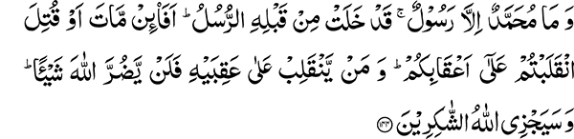
And Muhammad is but a messenger — messengers have already passed away before him. If then he dies or is killed, will you turn back upon your heels? And he who turns back upon his heels will do no harm at all to Allah. And Allah will reward the grateful. (3:144)
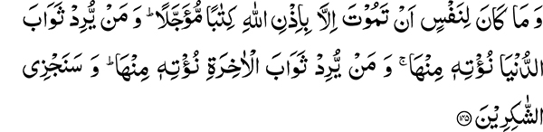
And no soul can die but with Allah’s permission — the term is fixed. And whoever desires the reward of this world, We give him of it, and whoever desires the reward of the Hereafter, We give him of it. And We shall reward the grateful. (3:145)
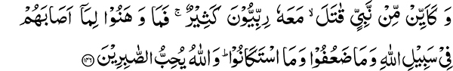
And how many a prophet has fought, with whom were many worshippers of the Lord. So they did not lose heart on account of that which befell them in Allah’s way, nor did they weaken, nor did they abase themselves. And Allah loves the steadfast. (3:146)
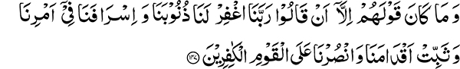
And their cry was only that they said: Our Lord, grant us protection from our sins and our extravagance in our affair, and make firm our feet and grant us victory over the disbelieving people. (3:147)
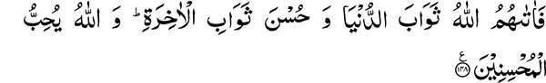
So Allah gave them the reward of the world and a good reward of the Hereafter. And Allah loves the doers of good (to others). (3:148)
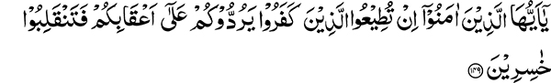
And Muhammad is but a messenger — messengers have already passed away before him. If then he dies or is killed, will you turn back upon your heels? And he who turns back upon his heels will do no harm at all to Allah. And Allah will reward the grateful.
These words provide Testimony that the Holy Quran is the Word of God. No one can use such words about himself whereby he comes under admonition by his own words. The Holy Quran has not only associated itself with the name of the Holy Prophet, wherein it is stated:
And obey Allah and obey the Messenger (64:12)
It has also praised the companions of the Holy Prophet. What is the reason that it also contains warnings such as in the verse I have recited? It proves without a doubt that the Holy Quran is not the word of the Holy Prophet but the Word of God.
Timing of this Revelation
The circumstances under which this verse was revealed were connected with the Battle of Uhud. In this battle the Muslims met with success early on in spite of being one fourth the number of the disbelievers. The disbelievers were initially routed and pursued by the Muslims. Subsequently due to an error in complying with the Holy Prophet’s instructions, the enemy got an opportunity to regroup and attack. This resulted in a setback for the Muslims and they were dispersed with only a few companions remaining with the Holy Prophet. The Holy Prophet then rallied his companions by calling out aloud, “Come towards me servants of Allah, I am the Messenger of Allah.” The result of this was obvious. As soon as the disbelievers heard this cry, they attacked the position where the Holy Prophet was. As a result of this concentrated assault the Holy Prophet was injured and fell down in a pit. His rallying cry was also heard by his companions who grouped and formed a protective cordon around him, bravely bearing the brunt of the enemy assault. When the enemy saw that the Muslims had rallied together, they felt it to be a good opportunity to retreat. In this battle the Holy Prophet sustained injury to his head and face. False rumor spread in the battlefield that the Holy Prophet had died. It is worth noting that when a general dies it is hard for his forces to fight.
The Companions Strength of Faith
Even if the Holy Prophet was a Great General or a King his followers would have lost their footing with these turn of events. The reason why the Companions fought on was something else. Not only was the Holy Prophet their leader and King but also their most beloved. Their example of fortitude and remaining steadfast under these circumstances is the most excellent one. One of the companions is known to have made these remarks: O believers if Muhammad has been killed, your fight was for Allah’s sake. Allah is Ever Living. So fight on for Allah, for whom Muhammad the Messenger of Allah (Peace and blessings of Allah be upon him) fought. There were some who were weak hearted. It was to admonish them these words were revealed:
And Muhammad is but a messenger — messengers have already passed away before him. If then he dies or is killed, will you turn back upon your heels? And he who turns back upon his heels will do no harm at all to Allah. And Allah will reward the grateful.
Glory be to Allah for the Purity of these teachings!
This verse teaches the believer the excellent degree of belief in Unity of God. It says:
If then he (the Messenger) dies or is killed, will you turn back upon your heels?
Will you then waiver in your belief in the Unity of the Divine Being?
It was such firm conviction and excellence of faith manifested by Hazrat Abu Bakr after the death of the Holy Prophet when he stood up and reminded the companions of this verse confirming that the Holy Prophet like all mortals had passed away.
Love for the Holy Prophet in the hearts of his Companions
The companions had an amazing degree of love for the Holy Prophet in their hearts. It has been expressed in this Hadith:
None amongst you is a believer unless his love for me (the Holy Prophet) is more than his love for his father and mother and all the people together.
They loved the Holy Prophet to such a degree that all the worldly love paled in comparison. His death was therefore a moment of profound grief for them. Ehsan BinThabit a well known poet and companion of the Holy Prophet compiled this poetic verse on the occasion of the Holy Prophet’s death:
Whosoever dies may die after your death
My fear was always of your passing away.
How Can such Excellence of belief in Divine Unity be Acquired?
Allah the Most High tells us that your belief in My Unity should be such that even the death of Muhammad the Messenger of Allah should not shake it and give you cause to turn on your heels. True belief is that even in the face of the greatest calamity you should continue in the way of Allah and keep on moving forward. The lesson for a believer is to be prepared to face all difficulties for the sake of the right principles.
An Exhortation and Lessons to be learned
I am exhorting you that you should also strive for such excellence of belief. If we also believe in a principle then no set back can turn us away from it. If you have taken up this belief simply to mimic someone else then your steps will falter in face of any adversity. Although, I believe you do not have such weaknesses. People say that the split in the Ahmadiyya movement has been a great setback for it. Remember that this is nothing in comparison with distress the companions faced at the death of the Holy Prophet. If you accepted a principle of belief as truthful with complete certainty then nothing can turn you back from it.
We cannot stray from the Real Purpose of our Lives as a result of the Current Differences
Ponder upon the task assigned to you by Hazrat Mirza Ghulam Ahmad. You will find it better than all your worldly pursuits. He called upon you to invite people towards Islam and made it the real purpose of your lives. Can someone have this doubt today that perhaps inviting towards Islam is not a noble task? Now what is it that can make you turn on your heels? Your task is Propagation of Islam. Has this split resulted in the propagation of Islam to come to a standstill? He who is dedicating his life, wealth and knowledge with full commitment is doing his work. For him who does not want to do anything this work does not appear to be much.
Success Depends Upon the Effort
Your job is to serve. Results are in the hands of God. You continue to propagate Islam, Allah the Most High has taken responsibility of your success upon Himself. Truth cannot cease to exist in the world. When those responsible for its spread, slow down in their efforts, the results are also hard to come by. It is, however, the law of Allah the Most High that if one organization refuses to propagate the truth, He makes another one stand in its place. Principles of Islam will prevail in the world because they are based upon the truth. That is why in the Holy Quran after enumerating them in the very beginning, Allah the Most High gives the promise of success for those who put them into practice. It is essential that there should be people who put them to practice. So you should continue to do the task you have been assigned. Your steps should not falter when it is time to act, in fact you should continue to make an effort and move forward in times of crisis. Do not fall back. If there is no effort made, you cannot expect a fruitful result. He who makes an effort does indeed succeed and the work of God is not to come to a standstill. If you do not perform this work, he will bring about other people in place of you to do His work. We observe that human effort is able to accomplish the most challenging tasks in the world. Take for example the concept of Trinity. It is against our common sense and observation and without any proof. It’s supporters who spend their wealth and put in an effort are however successful in gaining acceptance for their beliefs. This in spite of the fact that regarding it God says in the Holy Quran:
The heavens may almost be rent thereat, and the earth cleave asunder, and the mountains fall down in pieces, That they ascribe a son to the Beneficent! (19:90-91)
When a nation strives to gain acceptance for its beliefs, they make progress. There is nothing in the world that cannot be accomplished when an effort is made. If there is a shortcoming, it exists in our own souls.
Hardship and Suffering to be borne Patiently for the Cause of Islam
If you have passion and caring in your hearts for the cause of Islam, forego all your other desires for this purpose. Hardship and suffering becomes easy to bear for what one holds dear. For example if someone’s child is ill, he is willing to walk several miles in the middle of the night to get medicine for him. A mother whose child is sick remains up with him the whole night and does not feel any discomfort. If you want your numbers to increase in the world, there is only one way. It is for you to make a full effort and concentrate in doing your work.
Who are the Successful
It is improbable that you accept Hazrat Mirza Ghulam Ahmad as the Promised Messiah or have some supposed spiritual or physical connection with him and your success is guaranteed. Or that God’s work comes to a standstill because of this.
It is God’s promise:
And the Religion of Truth that He make it prevail over all religions. (9:33)
God will help those who help His religion. The purpose of the verse that I have recited at the beginning of this sermon is that man should not weaken his resolve in the face of the greatest loss or adversity. A belief should certainly be accepted with careful deliberation. When the truth of a matter is certain then it is not for the true believer in the Unity of God to manifest weakness. Allah the Most High follows with this statement:
And no soul can die but with Allah’s permission.
The word soul (nafs) here refers to Holy Prophet Muhammad. It was not time for him to die during events of Uhud. His pure soul had yet to purify many more.
Reward of the world in comparison to the reward of the Hereafter
The Holy Quran then says:
And whoever desires the reward of this world, We give him of it, and whoever desires the reward of the Hereafter, We give him of it.
In one place in the Holy Quran, Allah the Most High states that if He wished He could have given all the worldly gain to the disbelievers. What God is telling us is that He does not waste the effort we make for the world, why would He waste our striving for the Hereafter? He rewards good deeds with ten times their return. Whosoever makes an effort in His way, he gets a return far beyond what he hopes for.
It is then stated:
And how many a prophet has fought, with whom were many worshippers of the Lord.
Indicating history of the world bears witness that prophets have sometimes to take part in battle. The fact that the Holy Prophet was forced to fight in defense against the disbelievers is not contrary to the Divine law.
A Believer gains strength by fighting in self defence
The Quranic words that follow are:
So they did not lose heart on account of that which befell them in Allah’s way, nor did they weaken, nor did they abase themselves.
This shows that believers always have to face adversities in the way of Truth. These are meant to make their resolve stronger and not weak. The harder it gets, more resolute becomes the believer. So make a full effort, do not lose heart and pray to remain steadfast:
So Allah gave them the reward of the world and a good reward of the Hereafter. And Allah loves the doers of good (to others).
Compare the Words and Deeds of your Elders with your own
If we look at the spiritual condition of our elders and compare it with our own. We would come to the conclusion that many amongst us fall into the category described by the Holy Quran in these words:
And there are some people who say: We believe in Allah and the Last Day; and they are not believers. (2:8)
What is the reason that Arabs who were in a state of great moral decline were uplifted to the heights of spiritual excellence by the Companions of the Holy Prophet and why can we not accomplish a similar task if we try? We observed in our own time that wherever someone from our community went for propagation of religion, he was able to establish a group of followers. What is the problem now? It seems to be nothing besides this that those who did the work of propagation are getting sluggish in their effort. If you work with the same enthusiasm and energy, the reward of this world and the Hereafter will accompany you in your efforts.

And Muhammad is but a messenger — messengers have already passed away before him. If then he dies or is killed, will you turn back upon your heels? And he who turns back upon his heels will do no harm at all to Allah. And Allah will reward the grateful.

